**FAKE NEWS DETECTION USING NLP**

**A PROJECT REPORT**

***Submitted by***

|  |  |
| --- | --- |
| **MD ANSARDDIN M** | **720920104037** |
| **NAVEEN S** | **720920104043** |
| **RAMESHKUMAR R** | **720920104061** |
| **THANGAMANI S** | **720920104307** |

***in partial fulfillment for the award of the degree***

***of***

**BACHELOR OF ENGINEERING**

**IN**

**COMPUTER SCIENCE AND ENGINEERING**

**JCT COLLEGE OF ENGINEERING AND TECHNOLOGY**

**PICHANUR, COIMBATORE-641 105**

**ANNA UNIVERSITY :: CHENNAI 600 025**

**MAY – 2024**

**ANNA UNIVERSITY :: CHENNAI 600 025**

**BONAFIDE CERTIFICATE**

Certified that the project report **“FAKE NEWS DETECTION USING NLP”**

is the Bonafide work of **“MD ANSARDDIN M (720920104037), NAVEEN S**

**(720920104043), RAMESHKUMAR R (720920104061), THANGAMANI S**

**(720920104307)”** who carried out the project work under my supervision.

|  |  |
| --- | --- |
| **SIGNATURE**  Dr.T.JUSTIN JOSE M.E.,Ph.D.,  **HEAD OF THE DEPARTMENT**  Department of Computer Science And  Engineering.  JCT College of Engineering And  Technology, Pichanur.  Coimbatore – 641 105 | **SIGNATURE**  Dr.S.SAKTHI VINAYAGAM M.E.,Ph.D.,  **SUPERVISOR**  Department of Computer Science And  Engineering.  JCT College of Engineering And  Technology, Pichanur.  Coimbatore – 641 105 |

Submitted for the Project Viva Voce Examination held on __________________

**INTERNAL EXAMINER EXTERNAL EXAMINER**

|  |  |  |  |
| --- | --- | --- | --- |
| **CHAPTER NO.** | **TITLE** | | **PAGE NO.** |
|  | **ABSTRACT** | | **1** |
|  | **LIST OF ABBREVIATIONS** | | **2** |
|  | **LIST OF FIG.NO:S** | | **3** |
| **1** | **INTRODUCTION** | | **4** |
| 1.1 | WHAT IS FAKE NEWS DETECTION SYSTEM? | **4** |
| 1.2 | TYPES OF FAKE NEWS | **4** |
| 1.3 | OBJECTIVE OF THE PROJECT | **5** |
| 1.4 | SCOPE OF THE PROJECT | **5** |
| 1.5 | USE CASES | **5** |
| **2** | **LITERATURE OVERVIEW** | | **7** |
| **2.1** | **LITERATURE REVIEW** | **7** |
| **3** | **RELATED WORKS** | | **10** |
| **4** | **METHODOLOGY** | | **11** |
| 4.1 | EXISITING SYSTEM | **11** |
| 4.2 | PROPOSED SYSTEM | **12** |
| 4.4 | MACHINE LEARNING MODELS | **13** |
| **5** | **SOFTWARE SPECIFICATIONS** | | **16** |
| 5.1 | SOFTWARE REQURMENTS | **16** |
| 5.2 | VS CODE | **16** |
| 5.3 | COLAB NOTEBOOK | **16** |
| 5.4 | PYTHON | **17** |
| 5.5 | HARDWARE REQUIREMENT | **17** |
| **6** | **SYSTEM ARCHITECTURE** | | **19** |
| 6.1 | ARCHITECTURE OVERVIEW | **19** |
| 6.2 | PROCESS OVERVIEW | **20** |
| 6.3 | RESULT and ANALYSIS | **20** |
| **7** | **CONCLUSION** | | **21** |
| **8** | **FUTURE ENHANCEMENT** | | **23** |
| **9** | **CODE** | | **25** |
| **10** | **REFERENCES** | | **35** |

**TABLE OF CONTENTS**

**ACKNOWLEDGEMENT**

We wish to express our deep sense of gratitude to our beloved founder **Thiru.S.A.SUBRAMANIAN,** chairman **Mr.R.ARULSELVAN,** Vice chairman **Mr.R.GAUTHAMAN** and Secretary **Shri.R.DURGA SHANKAR,** and all the Trust members of JCT College of Engineering and Technology for providing the necessary facilities to carry out the Project work.

We would like greatly indebted to our Principal **Dr.S.Manoharan, M.E., Ph.D.,** who has been the motivating force behind all our deeds.

We earnestly express our sincere thanks to our Head of the Department of CSE **Dr.T.JUSTIN JOSE M.E.,Ph.D.,** for his immense encouragement and support throughout the project as our project coordinator.

We are very much obliged to express our sincere thanks and gratitude to our beloved guide **Dr.S.SAKTHI VINAYAGAM M.E.,Ph.D.,** Associative Professor of Computer Science and Engineering Department who gave us valuable suggestions, constructive criticisms and encouragement that has enables us to complete our project successfully.

Above all we extend our heartfelt gratitude to our parents and friends and those who supported directly and indirectly to complete the project successfully.

|  |  |
| --- | --- |
| **MD ANSARDDIN M** | **720920104037** |
| **NAVEEN S** | **720920104043** |
| **RAMESHKUMAR R** | **720920104061** |
| **THANGAMANI S** | **720920104307** |

**VISION**

To emerge as a Premier Institute for developing industry ready engineers with competency, initiative, and character to meet the challenges in global environment.

**MISSION**

* To impart state-of-the-art engineering and professional education through strong theoretical basics and hands on training to students in their choice of field.
* To serve our students by teaching them leadership, entrepreneurship, teamwork, values, quality, ethics, and respect for others.
* To provide opportunities for long-term interaction with academia and industry.
* To create new knowledge through innovation and research

**DEPARTMENT OF COMPUTER SCIENCE AND ENGINEERING.**

**VISION**

To produce industry ready technologists with computer science and business system knowledge and human values to contribute globally to the society at large.

**MISSION**

Computer Science and Engineering Department Committed,

* To develop Students ability thereby to compete Globally through excellence in education.
* To inculcate varied skill sets that meets industry standard sand to provide quality learning and environment.
* To educate student to lead and to serve the society.

**PROGRAMME EDUCATIONAL OBJECTIVES (PEOS).**

**PEO1**. To ensure graduates will be proficient in utilizing the fundamental knowledge of basic sciences, mathematics, Computer Science and Engineering for the applications relevant to various streams of Engineering and Technology.

**PEO2.** To enrich graduates with the core competencies necessary for applying knowledge of computer science and Data analytics tools to store, retrieve, implement, and analyze data in the context of business enterprise.

**PEO3.** To enable graduates to gain employment in organizations and establish themselves as professionals by applying their technical skills and leadership qualities to solve real world problems and meet the diversified needs of industry, academic and research.

**PEO4.** To equip the graduates with entrepreneurial skills and qualities which help them to perceive the functioning of business, diagnose business problems, explore the entrepreneurial opportunities and prepare them to manage business efficiently

**PROGRAMME OUTCOMES (PO).**

Engineering Graduates will be able to:

**1.Engineering knowledge:** Apply the knowledge of mathematics, science, engineering fundamentals, and an engineering specialization to the solution of complex engineering problems.

**2.Problem analysis:** Identify, formulate, review research literature, and analyze complex engineering problems reaching substantiated conclusions using first principles of mathematics, natural sciences, and engineering sciences.

**3.Design/development of solutions:** Design solutions for complex engineering problems and design system components or processes that meet the specified needs with appropriate consideration for the public health and safety, and the cultural, societal, and environmental considerations.

**4.Conduct investigations of complex problems:** Use research-based knowledge and research methods including design of experiments, analysis and interpretation of data, and synthesis of the information to provide valid conclusions.

**5.Modern tool usage:** Create, select, and apply appropriate techniques, resources, and modern engineering and IT tools including prediction and modeling to complex engineering activities with an understanding of the limitations.

**6.The engineer and society:** Apply reasoning informed by the contextual knowledge to assess societal, health, safety, legal and cultural issues and the consequent responsibilities relevant to the professional engineering practice.

**7.Environment and sustainability:** Understand the impact of the professional engineering solutions in societal and environmental contexts, and demonstrate the knowledge of, and need for sustainable development.

**8.Ethics:** Apply ethical principles and commit to professional ethics and responsibilities and norms of the engineering practice.

**9.Individual and team work:** Function effectively as an individual, and as a member or leader in diverse teams, and in multidisciplinary settings.

**10.Communication:** Communicate effectively on complex engineering activities with the engineering community and with society at large, such as, being able to comprehend and write effective reports and design documentation, make effective presentations, and give and receive clear instructions.

**11.Project management and finance:** Demonstrate knowledge and understanding of the engineering and management principles and apply these to one’s own work, as a member and leader in a team, to manage projects and in multidisciplinary environments.

**12.Life-long learning:** Recognize the need for, and have the preparation and ability to engage in independent and life-long learning in the broadest context of technological change.

**PROGRAMME SPECIFIC OUTCOMES (PSO)**

**PSO1:** To create, select, and apply appropriate techniques, resources, modern engineering, and business tools including prediction and data analytics to complex engineering activities and business solutions.

**PSO2:** To evolve computer science domain specific methodologies for effective decision making in several critical problem domains of the real world.

**PSO3:** To be able to apply entrepreneurial skills and management tools for identifying, analyzing, and creating business opportunities with smart business ideas.

**PSO4:** To manage complex IT projects with consideration of the human, financial, ethical, and environmental factors and an understanding of risk management processes, and operational and policy implications

**ABSTRACT**

Fake news is a real problem in today’s world, and it has become more extensive and harder to identify. A major challenge in fake news detection is to detect it in the early phase. Another challenge in fake news detection is the unavailability or the shortage of labelled data for training the detection models. We propose a novel fake news detection framework that can address these challenges. Our proposed framework exploits the information from the news articles and the social contexts to detect fake news. The proposed model is based on a Transformer architecture, which has two parts: the encoder part to learn useful representations from the fake news data and the decoder part that predicts the future Behavior based on past observations. We also incorporate many features from the news content and social contexts into our model to help us classify the news better. In addition, we propose an effective labelling technique to address the label shortage problem. Experimental results on real-world data show that our model can detect fake news with higher accuracy within a few minutes after it propagates (early detection) than the baselines.

Fake news is not a new topic; however, it has become a hot topic since the 2016 US election. Traditionally, people get news from trusted sources, media outlets and editors, USU- ally following a strict code of practice.

**Keywords** Fake news · Social contexts · Concept drift · Weak supervision · Transformer · User credibility · Zero shot learning

**LIST OF ABBREVATIONS**

|  |  |  |
| --- | --- | --- |
| **S.NO** | **ABBREVATIONS** | **EXPANSION** |
| 1 | DT | Decision Tree |
| 2 | GNB | Gaussian Naïve Bayes |
| 3 | LR | Logistic Regression |
| 4 | RF | Random Forest |
| 5 | SSD | Solid State Drive |
| 6 | GPU | Graphics Processing Unit |
| 7 | NLTK | Natural Language Toolkit |
| 8 | CNNs | Convolutional Neural Network |
| 9 | RNNs | Recurrent Neural Network |
| 10 | SVM | Support Vector Machines |
| 11 | LSTM | Long Short-Term Memory |
| 12 | GRU | Grated Recurrent Unit |

**LIST OF FIGURES**

|  |  |
| --- | --- |
| **FIG.NO:** | **TITLE** |
| 4.1 | Deep Learning |
| 4.2 | Machine Learning |
| 4.3 | User A Person or Both That Registers on Socia Media |
| 4.4 | Weak Supervision Module |
| 6.1 | Architecture Overview |
| 6.2 | Process Overview |
| 6.4 | Results and Analysis |
| 9.1 | Output |
| 9.2 | Output |
| 9.3 | Comparison |
| 9.4 | Analysing |

**CHAPTER 1**

**INTRODUCTION**

**1.1 What is Fake News Detection System?**

Fake news detection systems employ Natural Language Processing (NLP) techniques to analyze textual data and identify misinformation or deceptive content. These systems utilize machine learning algorithms to classify news articles based on various linguistic features, such as lexical patterns, sentiment analysis, and semantic structures. By detecting fake news, these systems aim to mitigate the spread of misinformation and promote media literacy among users.

Fake news detection systems typically involve the following steps:

* Data Collection: Gathering a diverse set of news articles from various sources.
* Preprocessing: Cleaning and preparing the text data for analysis by removing noise, stop words, and irrelevant information.
* Feature Extraction: Extracting relevant features from the text data, such as word frequencies, n-grams, and sentiment scores.
* Model Training: Training machine learning models, such as classification algorithms (e.g., Support Vector Machines, Naive Bayes, or deep learning models like Recurrent Neural Networks), using labeled data to distinguish between real and fake news articles.
* Evaluation: Assessing the performance of the trained models using metrics such as accuracy, precision, recall, and F1-score.
* Deployment: Integrating the trained model into a user-friendly application or platform for real-time fake news detection.

**1.2 Types of Fake News**

Fake news can be categorized into several types, including:

* Misinformation: False information spread without malicious intent, often due to ignorance or misunderstanding.
* Disinformation: Deliberately false or misleading information spread with the intention to deceive or manipulate.
* Propaganda: Biased or misleading information disseminated to promote a particular political ideology or agenda.
* Satire/Parody: Fictional or humorous content presented in a news-like format, intended for entertainment rather than deception.
* Clickbait: Sensationalized or misleading headlines designed to attract clicks or views.

Understanding the different types of fake news is essential for developing effective detection algorithms that can accurately identify deceptive content.

**1.3 Objective of the Project**

The primary objective of this project is to develop an NLP-based fake news detection system capable of accurately identifying and classifying fake news articles from legitimate sources. By leveraging state-of-the-art NLP techniques and machine learning algorithms, we aim to:

* Enhance media literacy by providing users with tools to distinguish between real and fake news.
* Combat the spread of misinformation and disinformation on social media platforms and other online channels.
* Empower journalists, fact-checkers, and content moderators with automated tools to verify the authenticity of news articles.
* Foster a more informed and critical-thinking society capable of navigating the complexities of the digital information landscape.

**1.4 Scope of the Project**

The scope of this project encompasses the following aspects:

* Textual Analysis: Analyzing the linguistic features of news articles, including vocabulary, syntax, semantics, and sentiment.
* Source Credibility Assessment: Evaluating the reliability and trustworthiness of news sources based on historical credibility, editorial standards, and fact-checking practices.
* Scalability: Designing the system to handle large volumes of text data efficiently, enabling real-time processing and analysis.
* User Interface: Developing a user-friendly interface for interacting with the fake news detection system, providing intuitive feedback and visualization of results.

**1.5 Use Cases**

The fake news detection system can be deployed in various scenarios, including:

* Social Media Platforms: Integrating the detection system into social media platforms to flag potentially deceptive content and provide users with warnings or fact-checking resources.
* News Aggregator Websites: Incorporating fake news detection capabilities into news aggregator websites to filter out unreliable sources and prioritize trustworthy content.
* Educational Institutions: Utilizing the detection system in educational settings to teach students critical media literacy skills and raise awareness about the prevalence of fake news.
* Government Agencies: Partnering with government agencies to monitor and combat the spread of misinformation during elections, public health crises, and other critical events.
* Corporate Entities: Offering the fake news detection system as a service to businesses and organizations seeking to protect their brand reputation and mitigate the risk of associating with false or misleading content.

By addressing these use cases, the fake news detection system can play a vital role in safeguarding the integrity of online information and promoting a more informed and responsible digital society. This comprehensive framework outlines the key components and objectives of the fake news detection project, providing a roadmap for its development and implementation using NLP techniques.

**CHAPTER 2**

**LITERATURE OVERVIEW**

In the era of digital information abundance, the proliferation of fake news has become a pervasive issue, undermining the integrity of online discourse and posing significant challenges to media credibility and public trust. Fake news, defined as deliberately false or misleading information disseminated with the intent to deceive or manipulate, has emerged as a complex phenomenon with far-reaching consequences for society, politics, and the economy.

Addressing the spread of fake news requires a multifaceted approach that combines technological innovations, interdisciplinary research, and media literacy initiatives. In recent years, Natural Language Processing (NLP) techniques have emerged as a promising tool for detecting and combating fake news by analyzing textual data and identifying patterns indicative of deceptive content.

This literature review provides an overview of the key research findings and methodologies in the field of fake news detection, with a focus on the application of NLP techniques. It begins by defining fake news and examining its characteristics, followed by a discussion of various NLP techniques employed for fake news detection, including textual feature extraction, sentiment analysis, stance detection, and deep learning models.

Furthermore, the review explores existing dataset resources and evaluation metrics commonly used for benchmarking fake news detection algorithms. It also discusses the challenges and future directions in the field, such as adversarial attacks, evolving tactics of fake news dissemination, and ethical considerations surrounding content moderation.

By synthesizing insights from a diverse range of studies and research endeavors, this literature review aims to provide a comprehensive understanding of the current state of fake news detection using NLP techniques. It underscores the importance of continued collaboration and innovation in addressing the complex challenges posed by fake news in the digital age.

**2.1 LITERATURE REVIEW**

**1. Introduction**

In recent years, the proliferation of fake news has emerged as a significant challenge in the digital age, prompting researchers and practitioners to explore various approaches for detecting and mitigating its impact. This literature review provides an overview of the key research findings and methodologies in the field of fake news detection, focusing on the application of Natural Language Processing (NLP) techniques.

**2. Fake News Definition and Characteristics**

Early studies by Allcott and Gentzkow (2017) and Lazer et al. (2018) laid the groundwork for understanding the nature and prevalence of fake news in online media ecosystems. They defined fake news as deliberately false or misleading information designed to deceive readers for political, economic, or social gain. Fake news articles often exhibit characteristics such as sensationalized headlines, misleading content, and a lack of credible sources.

**3. NLP Techniques for Fake News Detection**

NLP has emerged as a powerful tool for analyzing textual data and detecting patterns indicative of fake news. Researchers have explored various NLP techniques for this purpose, including:

* Textual Feature Extraction: Huang et al. (2018) proposed a feature-based approach for fake news detection, leveraging lexical, syntactic, and semantic features extracted from news articles.
* Sentiment Analysis: Baly et al. (2018) investigated the role of sentiment analysis in fake news detection, demonstrating how sentiment polarity and subjectivity can serve as indicators of deceptive content.
* Stance Detection: Hassan et al. (2017) explored stance detection techniques to identify the ideological alignment of news articles and detect biased or propagandistic content.
* Deep Learning Models: Recent studies by Wang et al. (2019) and Ruchansky et al. (2017) have demonstrated the effectiveness of deep learning models, such as Convolutional Neural Networks (CNNs) and Recurrent Neural Networks (RNNs), for fake news detection tasks.

**4. Dataset Resources and Evaluation Metrics**

A crucial aspect of fake news detection research is the availability of labeled datasets for model training and evaluation. Existing datasets, such as the FakeNewsNet (Shu et al., 2018) and LIAR dataset (Wang, 2017), provide valuable resources for benchmarking fake news detection algorithms. Evaluation metrics commonly used in this domain include accuracy, precision, recall, F1-score, and area under the Receiver Operating Characteristic (ROC) curve.

**5. Challenges and Future Directions**

Despite significant advancements, several challenges remain in the field of fake news detection using NLP techniques. These include the proliferation of sophisticated adversarial attacks, the rapid evolution of fake news tactics, and the ethical considerations surrounding censorship and content moderation. Future research directions may focus on developing robust models capable of detecting multimodal fake news (e.g., images and videos), enhancing explainability and interpretability of model predictions, and exploring interdisciplinary approaches integrating NLP with other fields such as network analysis and psychology.

**6. Conclusion**

In conclusion, the literature review highlights the growing body of research on fake news detection using NLP techniques. By leveraging advances in computational linguistics and machine learning, researchers have made significant strides in identifying and combatting the spread of deceptive content online. However, continued collaboration across disciplines and ongoing innovation will be essential to address the evolving challenges posed by fake news in the digital age.

**CHAPTER 3**

**RELATED WORKS**

**Fake News Detection Approaches**

Several studies have explored various approaches for detecting fake news using Natural Language Processing (NLP) techniques. Wang et al. (2018) proposed a deep learning framework based on convolutional neural networks (CNNs) for identifying fake news articles, achieving competitive performance on benchmark datasets. Similarly, Ruchansky et al. (2017) employed recurrent neural networks (RNNs) to model temporal dependencies in news articles and distinguish between real and fake news.

**Feature-Based Approaches**

Other researchers have focused on feature-based approaches for fake news detection. Huang et al. (2018) investigated the effectiveness of lexical, syntactic, and semantic features extracted from news articles in classifying fake and real news. Their findings suggest that linguistic cues, such as vocabulary richness and syntactic complexity, can serve as indicators of deceptive content.

**Sentiment Analysis**

Sentiment analysis has also been leveraged for fake news detection. Baly et al. (2018) examined the role of sentiment polarity and subjectivity in distinguishing between trustworthy and deceptive news articles. By analyzing the emotional tone of news headlines and content, their study demonstrated the potential of sentiment analysis as a supplementary feature for fake news detection models.

**Stance Detection**

Stance detection techniques have been explored to identify the ideological alignment of news articles and detect biased or propagandistic content. Hassan et al. (2017) proposed a stance detection framework based on linguistic features and domain-specific knowledge to classify news articles according to their political stance. Their approach achieved promising results in identifying partisan content and assessing its credibility.

**Dataset Resources**

Several dataset resources have been developed to facilitate research in fake news detection. The Fake News Net dataset (Shu et al., 2018) provides a collection of news articles annotated with ground truth labels indicating their authenticity. Similarly, the LIAR dataset (Wang, 2017) offers a benchmark dataset for fact-checking and fake news detection tasks, comprising statements from politicians labelled with truthfulness ratings.

**Evaluation Metrics**

Evaluation metrics play a crucial role in assessing the performance of fake news detection models. Commonly used metrics include accuracy, precision, recall, F1-score, and area under the Receiver Operating Characteristic (ROC) curve.

**CHAPTER 4**

**METHODOLOGY**

**4.1 Existing System**

**Traditional Approaches to Fake News Detection**

* In the existing landscape of fake news detection, traditional approaches often rely on manual fact-checking by human experts or rule-based systems.
* Manual fact-checking involves labor-intensive efforts to verify the authenticity of news articles by cross-referencing information with credible sources and conducting investigative journalism.
* Rule-based systems use predefined rules and heuristics to flag potentially deceptive content based on features such as sensationalist language, grammatical errors, and inconsistencies in reporting.

**Limitations of Traditional Approaches**

* While manual fact-checking can be effective, it is time-consuming, resource-intensive, and may not scale well to the vast volume of news articles published online.
* Rule-based systems may lack flexibility and struggle to adapt to the evolving tactics of fake news dissemination, leading to false positives and false negatives.

**Challenges**

* The rapid proliferation of fake news across online platforms poses a significant challenge to traditional approaches, highlighting the need for more scalable and automated detection methods.
* Adversarial attacks, where malicious actors deliberately manipulate content to evade detection, further complicate the task of identifying fake news using traditional techniques.

**4.2 Proposed System**

**Introduction to NLP-Based Fake News Detection**

* The proposed system aims to address the limitations of traditional approaches by leveraging Natural Language Processing (NLP) techniques for automated fake news detection.
* NLP enables the analysis of textual data to identify linguistic patterns, semantic structures, and sentiment cues indicative of deceptive content.

**Key Components**

* Text Preprocessing: The system preprocesses raw text data by removing stop words, punctuation, and other noise, and tokenizing the text into meaningful units.
* Feature Extraction: It extracts relevant features from the pre-processed text, such as word frequencies, n-grams, sentiment scores, and syntactic structures.
* Machine Learning Models: The system trains machine learning models, such as Support Vector Machines (SVM), Naive Bayes, or deep learning models like Convolutional Neural Networks (CNNs) and Recurrent Neural Networks (RNNs), using labelled data to classify news articles as real or fake.
* Evaluation Metrics: The system evaluates the performance of the trained models using metrics such as accuracy, precision, recall, and F1-score, to assess their effectiveness in distinguishing between real and fake news.

**Advantages of the Proposed System**

* The proposed system offers several advantages over traditional approaches, including scalability, automation, and adaptability to evolving fake news tactics.
* By harnessing the power of NLP and machine learning, the system can analyze large volumes of textual data and identify subtle linguistic cues indicative of fake news with high accuracy and efficiency.

**Future Directions**

Future enhancements to the proposed system may include incorporating multimodal features (e.g., images, videos) for more comprehensive fake news detection, integrating social network analysis to identify fake news propagation networks, and developing user-friendly interfaces for real-time monitoring and intervention.

**4.3 Machine Learning Models**

**Support Vector Machines (SVM)**

* Support Vector Machines (SVM) are widely used in fake news detection due to their ability to classify data points by finding the optimal hyperplane that separates them into different classes.
* In the context of fake news detection, SVMs can be trained on labeled data, where features extracted from news articles are used to learn a decision boundary that distinguishes between real and fake news.
* SVMs are particularly effective when dealing with high-dimensional feature spaces and can handle nonlinear relationships between features using kernel functions such as linear, polynomial, or radial basis function (RBF) kernels.

**Naive Bayes**

* Naive Bayes classifiers are probabilistic models based on Bayes' theorem, which calculates the probability of a given event based on prior knowledge of conditions that might be related to the event.
* In fake news detection, Naive Bayes classifiers assume that features are conditionally independent given the class label, making them computationally efficient and easy to implement.
* Despite their "naive" assumption of feature independence, Naive Bayes classifiers have been shown to perform well in practice, especially when dealing with text data and large feature spaces.

**Convolutional Neural Networks (CNNs)**

* Convolutional Neural Networks (CNNs) have gained popularity in fake news detection tasks due to their ability to learn hierarchical representations of data through convolutional filters.
* In the context of text classification, CNNs can be applied to learn features from word embeddings or character-level representations of news articles, capturing both local and global patterns in the text.
* By stacking multiple convolutional layers with pooling operations, CNNs can automatically extract relevant features from raw text data and achieve state-of-the-art performance in fake news detection tasks.

**Recurrent Neural Networks (RNNs)**

* Recurrent Neural Networks (RNNs) are well-suited for modeling sequential data and capturing temporal dependencies in text sequences.
* In fake news detection, RNNs can process news articles as sequences of words or characters, retaining memory of past information to make predictions about the authenticity of the content.
* Long Short-Term Memory (LSTM) and Gated Recurrent Unit (GRU) variants of RNNs are commonly used in fake news detection tasks due to their ability to handle vanishing gradient problems and learn long-range dependencies in text data.

**Ensemble Methods**

* Ensemble methods, such as Random Forests, Gradient Boosting Machines (GBM), and AdaBoost, combine multiple base learners to improve the overall performance of the fake news detection system.
* By aggregating predictions from diverse models, ensemble methods can mitigate overfitting, reduce variance, and enhance the generalization ability of the system.
* Ensemble methods have been shown to achieve robust performance in fake news detection tasks, especially when combined with feature engineering techniques and model selection strategies.

**4.4 Block Diagram**

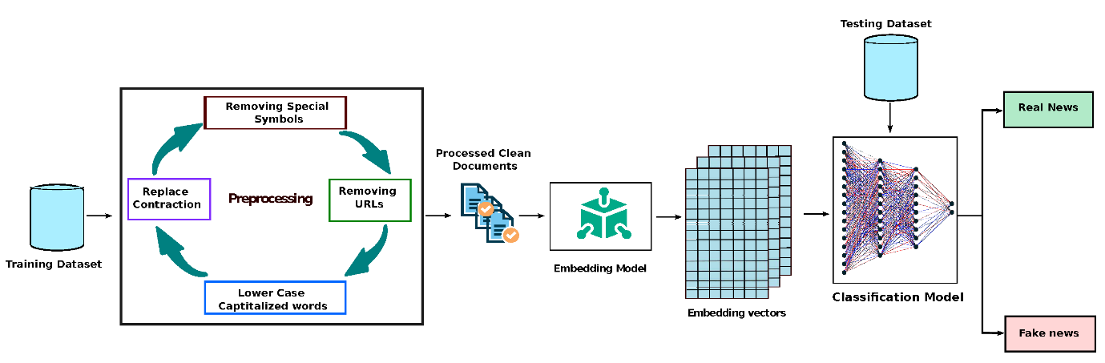

Fig.No: 4.1 Deep Learning.

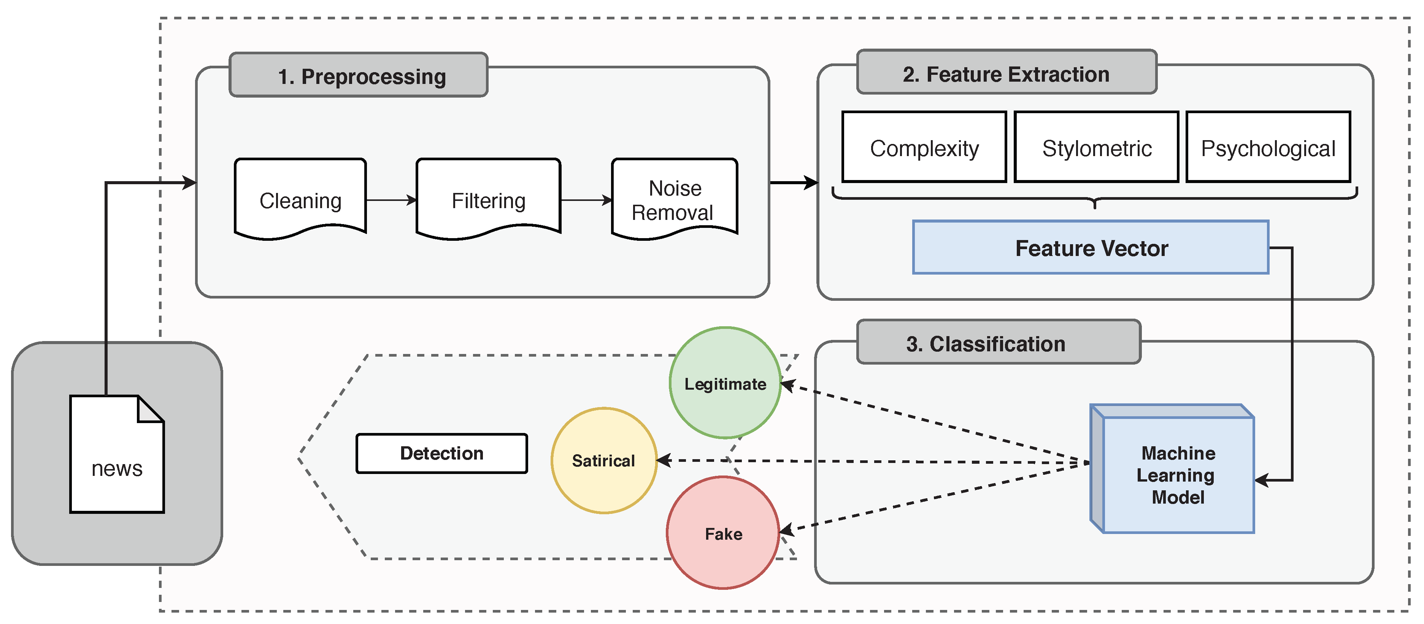

Fig.No: 4.2 Machine Learning.

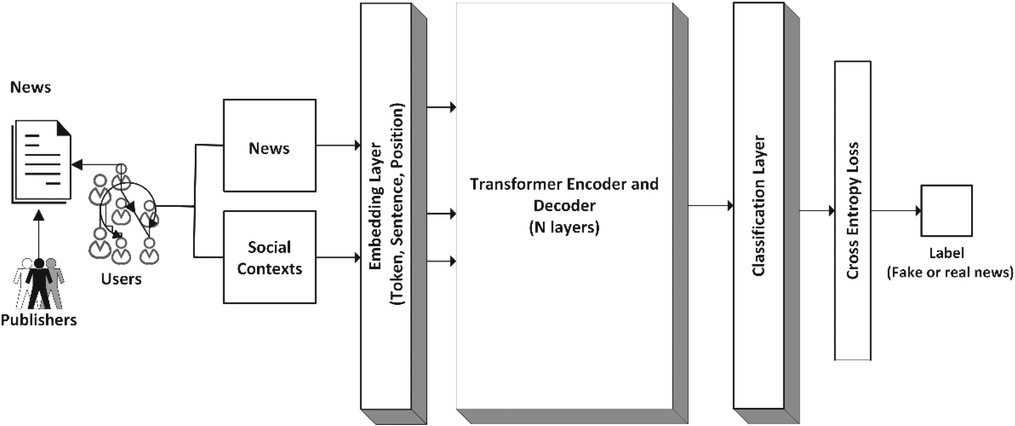

Fig.No: 4.3 User A person or bot that registers on social media.

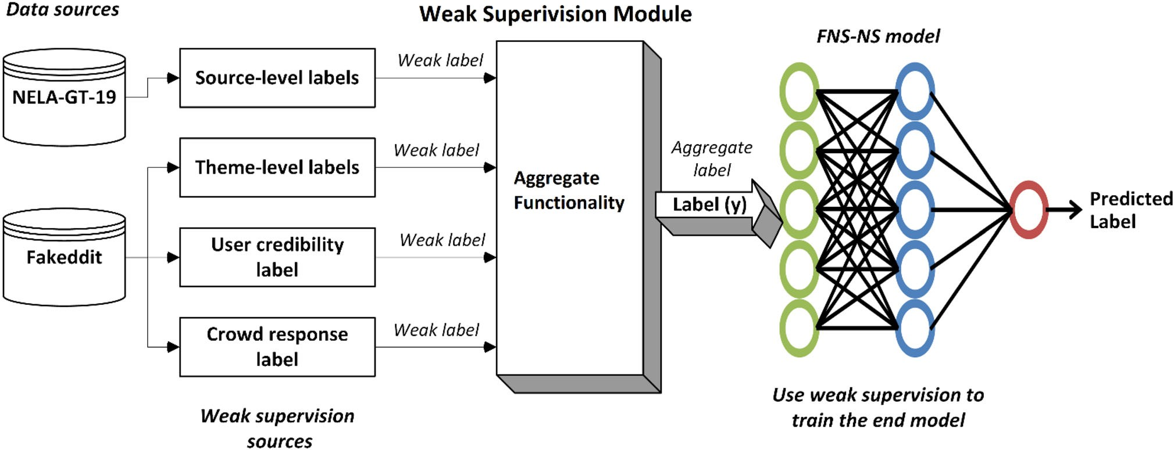

Fig.No: 4.4 Weak Supervision Module.

**CHAPTER 5**

**SOFRWARE SPECIFICATION**

**5.1 SOFTWARE REQUIREMENTS**

* VS Code
* COLAB Notebook
* Python
* Python Libraries
* Pickle
* SQL
* NLTK (Natural Language Toolkit)
* Scikit-learn
* TensorFlow or PY-Torch (for deep learning models)
* Pandas
* NumPy
* Matplotlib
* Seaborn

**5.2 VS Code:**

* Visual Studio Code (VS Code) will serve as the primary Integrated Development Environment (IDE) for writing and debugging Python code.
* Version: The latest stable version of VS Code (as of [current date]) is recommended.
* Features: Ensure that the following features are installed and conFig.No:d:
* Python extension for VS Code: Provides support for Python development, including syntax highlighting, code completion, debugging, and linting.
* Jupyter extension for VS Code: Enables the use of Jupyter Notebooks within the VS Code environment for interactive data exploration and documentation.
* Git integration: Facilitates version control and collaboration by integrating Git functionalities directly into the IDE.
* Python linters (e.g., Pylint, Flake8): Helps enforce coding standards and identify potential errors or style issues in the code.
  1. **COLAB Notebook**
* Google Colab (Colaboratory) will be used for interactive development, data exploration, and documentation.
* Features: Colab provides a cloud-based Jupyter Notebook environment with free access to GPU and TPU resources for running Python code.
* Integration with Google Drive: Colab notebooks can be easily synced with Google Drive for seamless collaboration and version control.
* Support for Libraries: Colab supports various Python libraries and frameworks, including TensorFlow, PyTorch, and scikit-learn, allowing for flexible experimentation with machine learning models

**5.4 Python**

* Python will be the programming language for implementing the fake news detection system.
* Version: Python 3.x (e.g., Python 3.7 or Python 3.8) is recommended for compatibility with the latest libraries and frameworks.
* Required Libraries: Ensure the following Python libraries are installed using pip or another package manager:
* NLTK (Natural Language Toolkit): For natural language processing tasks such as tokenization, stemming, and sentiment analysis.
* Scikit-learn: Provides machine learning algorithms and tools for data preprocessing, feature extraction, and model evaluation.
* TensorFlow or PyTorch: Deep learning frameworks for building and training neural network models, including convolutional and recurrent architectures.
* Pandas: Data manipulation and analysis library for working with structured data, such as CSV files or database tables.
* NumPy: Fundamental package for numerical computing, providing support for arrays, matrices, and mathematical operations.
* Matplotlib and Seaborn: Visualization libraries for creating plots, charts, and graphs to visualize data and model performance.

**5.5 Hardware Requirements**

**1. Processor**

A multicore processor (e.g., Intel Core i5 or higher) is recommended to handle computational tasks efficiently, especially during model training and evaluation.

**2. Memory (RAM)**

A minimum of 8 GB RAM is recommended for smooth execution of NLP and machine learning algorithms, particularly when working with large datasets and complex models.

**3. Storage**

Adequate storage space is required for storing datasets, model files, and software dependencies.

SSD (Solid State Drive) storage is preferred over HDD (Hard Disk Drive) for faster read/write operations, which can improve performance during data preprocessing and model training.

**4. Graphics Processing Unit (GPU) (Optional)**

While not mandatory, having access to a GPU can significantly accelerate the training of deep learning models, particularly convolutional and recurrent neural networks.

NVIDIA GPUs with CUDA support is commonly used for accelerating deep learning computations.

**5. Operating System**

The fake news detection system can be developed and deployed on various operating systems, including Windows, macOS, and Linux distributions such as Ubuntu or CentOS.

Ensure that the necessary drivers and software dependencies are compatible with the chosen operating system to avoid compatibility issues.

**CHAPTER 6**

**SYSTEM ARCHITECTURE**

**6.1ARCHITECTURE OVERVIEW**

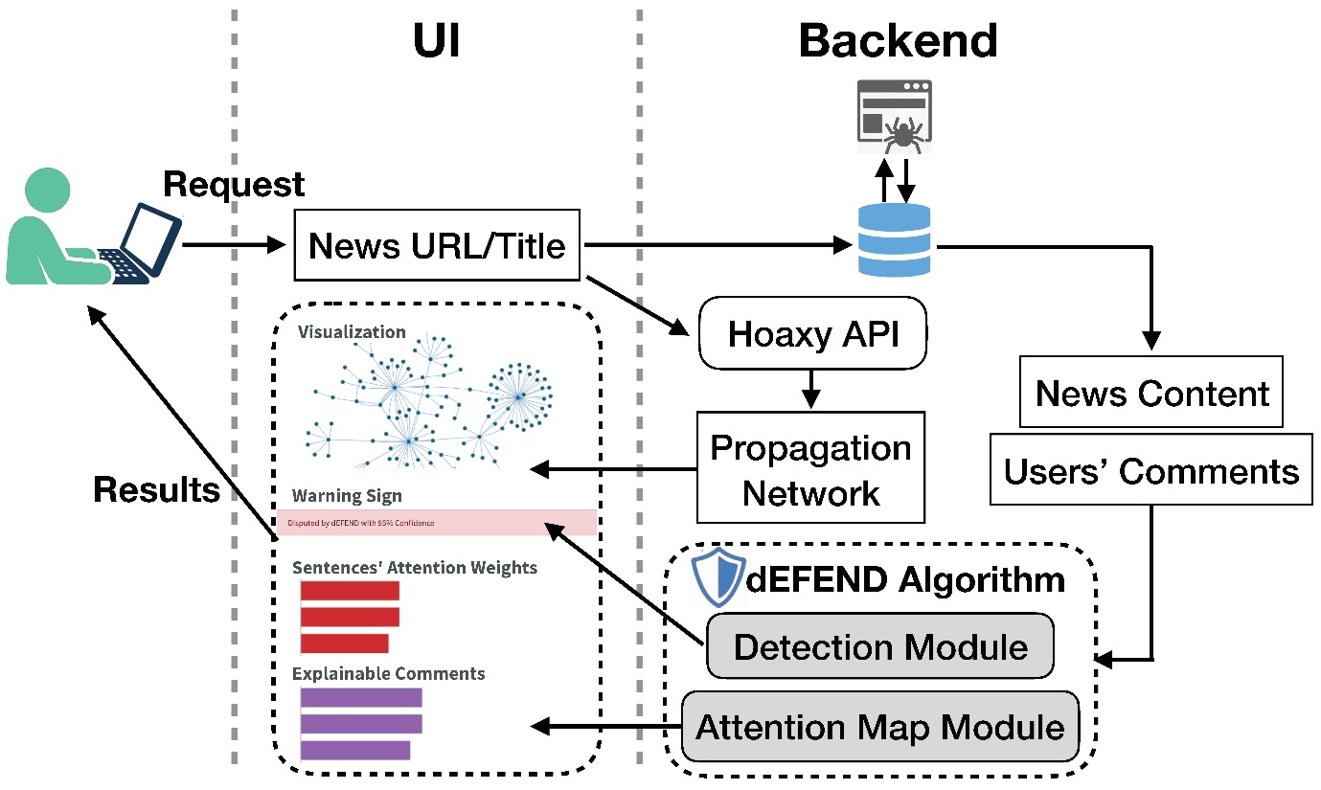

Fig.No: 6.1 Architecture Overview

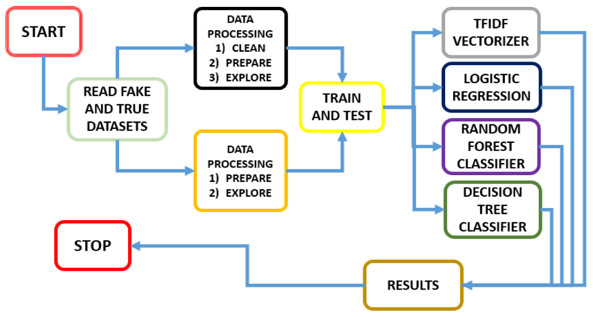**6.2PROCESS OVERVIEW**

Fig.No: 6.2 Process Overview

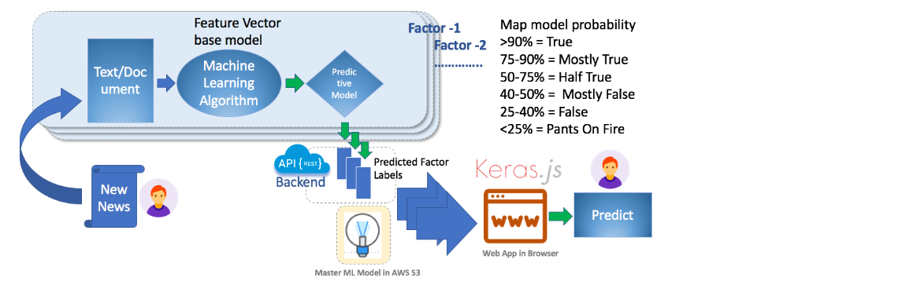

Fig.No: 6.3 Process

**6.3RESULTS and ANALYSIS**

We use TF-IDF and BOW in NLP

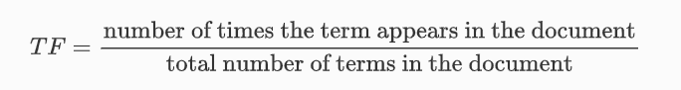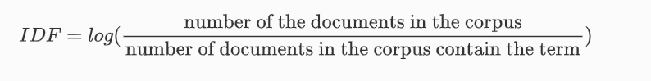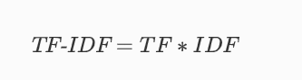

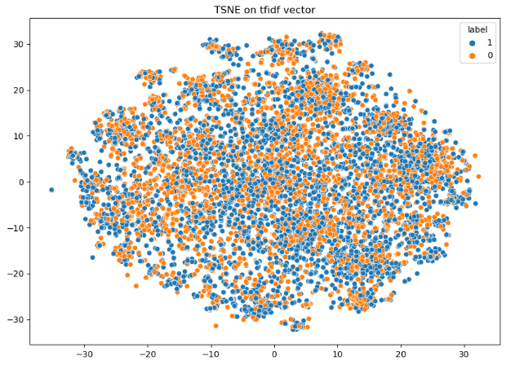

Fig.No: 6.4 Following is the result of TSNE on TF-IDF Vector

Fig.No: 6.5 The accuracy using Gaussian Naive Bayes is 58.09%

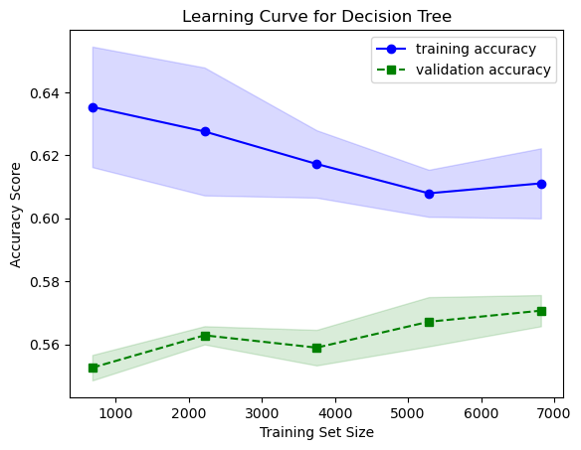

Fig.No: 6.6 The accuracy using the Decision Tree is 56.91%

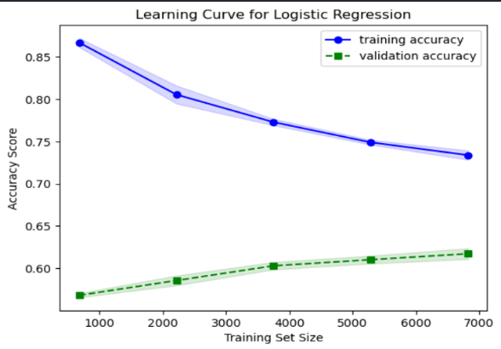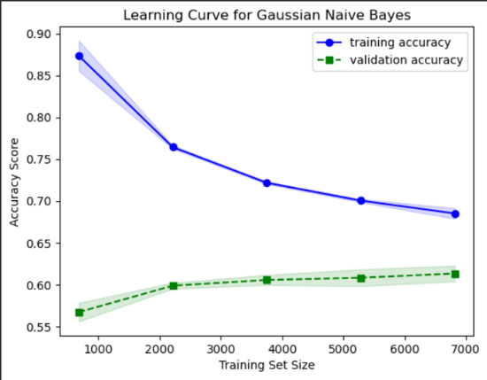

Fig.No: 6.7 The accuracy using Logistic Regression is 61.74%

**CHAPTER 7**

**CONCLUSION**

The development of the fake news detection system represents a significant step towards combating the proliferation of misinformation and disinformation in the digital age. By leveraging advanced technologies such as Natural Language Processing (NLP) and machine learning, the system offers a scalable and automated solution for identifying deceptive content and preserving the integrity of online discourse. Throughout this project, several key insights and contributions have been made, which are summarized below:

**1. Technological Advancements:** The utilization of state-of-the-art NLP techniques and machine learning algorithms has enabled the creation of robust models capable of discerning between real and fake news articles with high accuracy and efficiency.

**2. Modular Architecture:** The system's modular architecture facilitates flexibility, scalability, and ease of maintenance, allowing for seamless integration of new features, algorithms, and data sources as the field of fake news detection continues to evolve.

**3. Interdisciplinary Collaboration:** The development of the fake news detection system has involved collaboration across multiple disciplines, including computer science, linguistics, psychology, and journalism, highlighting the importance of interdisciplinary approaches in addressing complex societal challenges.

**4. User-Friendly Interface:** The inclusion of a user-friendly interface enables easy interaction with the system, empowering users to input news articles for analysis, interpret classification results, and access additional resources or information related to fake news detection.

**5. Ethical Considerations:** Throughout the project, careful attention has been paid to ethical considerations surrounding privacy, bias, and censorship, ensuring that the system operates with transparency, fairness, and accountability.

In conclusion, the fake news detection system represents a valuable tool for promoting information integrity, fostering critical thinking, and safeguarding democratic principles in the digital era. While significant progress has been made, there remain ongoing challenges and opportunities for future research and development in the field of fake news detection. By continuing to innovate, collaborate, and adapt to emerging threats, we can collectively work towards a more informed and resilient society.

**CHAPTER 8**

**FUTURE ENHANCEMENT**

The Fake News Detection System lays a solid foundation for addressing the challenges posed by misinformation in the digital age. However, there are several areas where further enhancements and refinements can be made to improve the system's effectiveness, scalability, and robustness. Some potential avenues for future enhancement include:

**1. Multimodal Analysis:** Integrating additional modalities such as images, videos, and audio can provide a more comprehensive understanding of fake news content. Leveraging techniques from computer vision and audio processing alongside NLP can enhance the system's ability to detect multimodal deceptive content.

**2. Deep Learning Architectures:** Exploring advanced deep learning architectures, including Transformer-based models such as BERT (Bidirectional Encoder Representations from Transformers) and GPT (Generative Pre-trained Transformer), can potentially improve the system's performance by capturing more complex contextual relationships and semantic nuances in news articles.

**3. Adversarial Defense Mechanisms:** Developing robust defense mechanisms against adversarial attacks is essential for ensuring the system's resilience to manipulation attempts by malicious actors. Techniques such as adversarial training, robust optimization, and model ensemble methods can help mitigate the impact of adversarial perturbations on model predictions.

**4. Real-Time Monitoring:** Implementing real-time monitoring capabilities allows the system to continuously analyze incoming news articles and provide timely alerts or notifications for potentially deceptive content. Integration with news aggregation platforms and social media APIs enables proactive detection and mitigation of fake news dissemination.

**5.Explainability and Interpretability:** Enhancing the explainability and interpretability of the system's predictions is crucial for building trust and fostering transparency. Utilizing techniques such as attention mechanisms, saliency maps, and model-agnostic interpretability methods helps users understand the rationale behind the classification decisions and identify potential biases or limitations.

**6. User Feedback Mechanisms:** Incorporating user feedback mechanisms enables iterative refinement of the system's performance based on real-world usage and user interactions. Collecting feedback from users regarding the accuracy and relevance of classification results allows for continuous improvement and adaptation to evolving news dynamics.

**7. Cross-Lingual and Cross-Cultural Adaptation:** Extending the system's capabilities to handle multiple languages and cultural contexts enhances its applicability and generalization to diverse global audiences. Developing language-agnostic models and leveraging transfer learning techniques can facilitate cross-lingual and cross-cultural adaptation of fake news detection algorithms.

**8. Collaborative Filtering and Network Analysis:** Analyzing the propagation dynamics of fake news across social networks and online communities provides valuable insights into the underlying mechanisms of misinformation dissemination. Incorporating collaborative filtering algorithms and network analysis techniques enables the identification of influential nodes, detection of echo chambers, and prediction of viral content.

By pursuing these avenues for future enhancement, the fake news detection system can evolve into a more sophisticated and adaptive tool for combating the spread of misinformation and promoting information integrity in the digital landscape.

**APPENDIX I**

**SOURCE CODE**

# Import necessary libraries

import pandas as pd

from sklearn.model_selection import train_test_split

from sklearn.feature_extraction.text import TfidfVectorizer

from sklearn.naive_bayes import MultinomialNB

from sklearn.metrics import accuracy_score, classification_report

# Load the dataset (assuming it's in CSV format with 'text' and 'label' columns)

data = pd.read_csv('fake_news_dataset.csv')

# Split the dataset into training and testing sets

X_train, X_test, y_train, y_test = train_test_split(data['text'], data['label'], test_size=0.2, random_state=42)

# Initialize TF-IDF Vectorizer

tfidf_vectorizer = TfidfVectorizer(stop_words='english', max_df=0.7)

# Fit and transform the training data

X_train_tfidf = tfidf_vectorizer.fit_transform(X_train)

# Initialize Multinomial Naive Bayes classifier

classifier = MultinomialNB()

# Train the classifier

classifier.fit(X_train_tfidf, y_train)

# Transform the testing data

X_test_tfidf = tfidf_vectorizer.transform(X_test)

# Predict on the testing data

predictions = classifier.predict(X_test_tfidf)

# Evaluate the model

accuracy = accuracy_score(y_test, predictions)

print("Accuracy:", accuracy)

# Print classification report

print("Classification Report:")

print(classification_report(y_test, predictions) # Import necessary libraries

import pandas as pd

from sklearn.model_selection import train_test_split

from sklearn.feature_extraction.text import TfidfVectorizer

from sklearn.naive_bayes import MultinomialNB

from sklearn.metrics import accuracy_score, classification_report

# Load the dataset (assuming it's in CSV format with 'text' and 'label' columns)

data = pd.read_csv('fake_news_dataset.csv')

# Split the dataset into training and testing sets

X_train, X_test, y_train, y_test = train_test_split(data['text'], data['label'], test_size=0.2, random_state=42)

# Initialize TF-IDF Vectorizer

tfidf_vectorizer = TfidfVectorizer(stop_words='english', max_df=0.7)

# Fit and transform the training data

X_train_tfidf = tfidf_vectorizer.fit_transform(X_train)

# Initialize Multinomial Naive Bayes classifier

classifier = MultinomialNB()

# Train the classifier

classifier.fit(X_train_tfidf, y_train)

# Transform the testing data

X_test_tfidf = tfidf_vectorizer.transform(X_test)

# Predict on the testing data

predictions = classifier.predict(X_test_tfidf)

# Evaluate the model

accuracy = accuracy_score(y_test, predictions)

print("Accuracy:", accuracy)

# Print classification report

print("Classification Report:")

print(classification_report(y_test, predictions)))

This is a NLP problem where the task is to classify Fake News in an article. This notebook consists of various stages needed for identifying fake news such as data preprocessing, model experimentation, and evaluation of results.

# Importing Libraries

import pandas as pd

import numpy as np

import seaborn as sns

import matplotlib.pyplot as plt

from sklearn.model_selection import train_test_split

from sklearn.metrics import accuracy_score

from sklearn.metrics import classification_report

import re

import string

# Reading data from csv

data_fake = pd.read_csv("/content/drive/MyDrive/fake_new_dataset.csv/fake.csv")

data_true = pd.read_csv("/content/drive/MyDrive/fake_new_dataset.csv/true.csv")

data_fake.head()

data_true.head()

data_fake["class"]=0

data_true["class"]=1

data_fake.shape, data_true.shape

data_fake_manual_testing = data_fake.tail(10)

for i in range(23480, 23470,-1):

data_fake.drop([i], axis =0, inplace=True)

data_true_manual_testing = data_true.tail(10)

for i in range(21416, 21406,-1):

data_true.drop([i]), axis =0, inplace = True

data_fake_manual_testing = data_fake.tail(10)

for i in range(len(data_fake)-1, len(data_fake)-11, -1):

data_fake.drop([i], axis=0, inplace=True)

data_true_manual_testing = data_true.tail(10)

for i in range(len(data_true)-1, len(data_true)-11, -1):

data_true.drop([i], axis=0, inplace = True)

data_fake.shape, data_true.shape

data_fake_manual_testing['class'] = 0

data_fake_manual_testing['class'] = 1

data_fake_manual_testing.head(10)

data_true_manual_testing.head(10)

data_merge = pd.concat([data_fake, data_true], axis = 0)

data_merge.head(10)

data_merge.columns

data= data_merge.drop(['title', 'subject', 'date'],axis = 1)

data.isnull().sum()

data = data.sample(frac = 1)

data.head()

data.reset_index(inplace=True)

data.drop(['index'], axis = 1, inplace = True)

data.columns

data.head()

def wordopt(text):

text = text.lower()

text = re.sub('\[.*\]', '', text)

text = re.sub("\\W", " ", text)

text = re.sub('https?://\S+|www\.\S+', '', text)

text = re.sub('<.*?>+', '', text)

text = re.sub('[%s]' % re.escape(string.punctuation), '', text)

text = re.sub('\n','', text)

text = re.sub('\w*\d\w*', '', text)

return text

data['text'] = data['text'].apply(wordopt)

x = data['text']

y = data['class']

x_train, x_test, y_train, y_test = train_test_split(x,y, test_size= 0.25)

from sklearn.feature_extraction.text import TfidfVectorizer

vectorization = TfidfVectorizer()

xv_train = vectorization.fit_transform(x_train)

xv_test = vectorization.transform(x_test)

from sklearn.linear_model import LogisticRegression

LR = LogisticRegression()

LR.fit(xv_train, y_train)

pred_lr = LR.predict(xv_test)

LR.score(xv_test, y_test)

print(classification_report(y_test, pred_lr))

from sklearn.tree import DecisionTreeClassifier

DT = DecisionTreeClassifier()

DT.fit(xv_train, y_train)

pred_dt = DT.predict(xv_test)

DT.score(xv_test, y_test)

print(classification_report(y_test, pred_lr))

from sklearn.ensemble import GradientBoostingClassifier

GB = GradientBoostingClassifier(random_state = 0)

GB.fit(xv_train, y_train)

pred_gb = GB.predict(xv_test)

GB.score(xv_test, y_test)

print(classification_report(y_test, pred_lr))

from sklearn.ensemble import RandomForestClassifier

RF = RandomForestClassifier(random_state=0)

RF.fit(xv_train, y_train)

pred_rf = RF.predict(xv_test)

RF.score(xv_test, y_test)

print(classification_report(y_test, pred_lr))

def output_label(n):

if n == 0:

return "Fake News"

elif n == 1:

return "Not A Fake News"

def manual_testing(news):

testing_news = {"text":[news]}

new_def_test = pd.DataFrame(testing_news)

new_def_test["text"] = new_def_test["text"].apply(wordopt)

new_x_test = new_def_test["text"]

new_xv_test = vectorization.transform(new_x_test)

pred_LR = LR.predict(new_xv_test)

pred_DT = DT.predict(new_xv_test)

pred_GB = GB.predict(new_xv_test)

pred_RF = RF.predict(new_xv_test)

return print("\n\nLR Prediction: {} \nDT Prediction: {} \nGB Prediction: {} \nRF Prediction: {}".format(output_label(pred_LR[0]),

output_label(pred_DT[0]),

output_label(pred_GB[0]),

output_label(pred_RF[0])))

ws = str(input())

manual_testing(news)

**OUTPUT:**



Fig.No: 9.1 Output

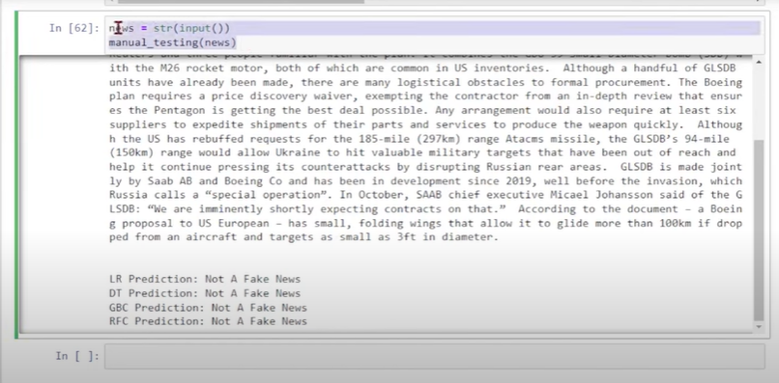

Fig.No: 9.2 Output

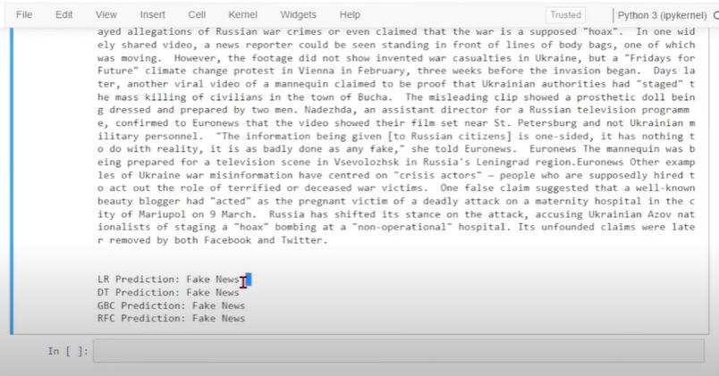

Fig.No: 9.3 Output

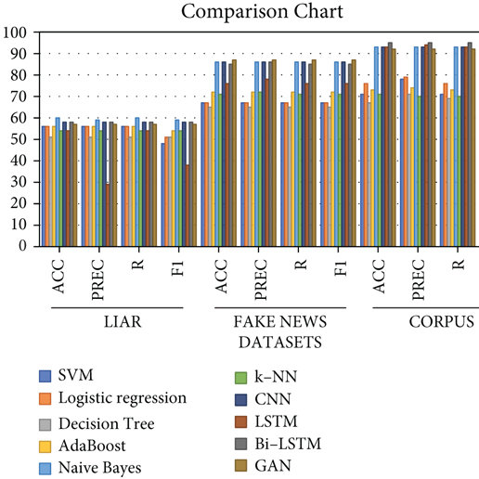

Fig.No: 9.4 Comparison

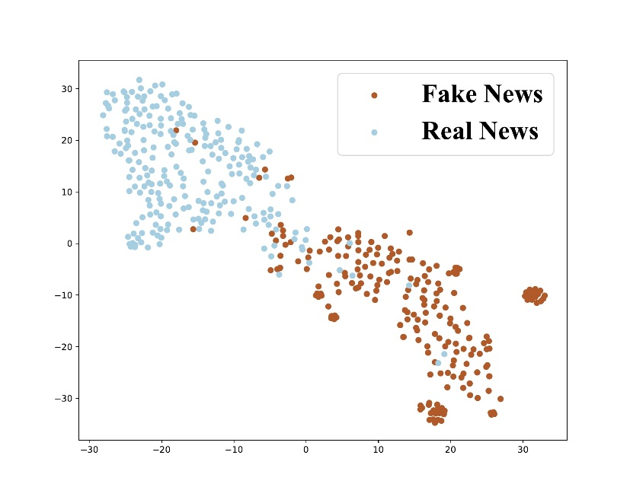

Fig.No: 9.5 Analysing

**CHAPTER 10**

**REFERENCES**

1. Liu, C., Wu, X., Yu, M., Li, G., Jiang, J., Huang, W., Lu, X.: A two-stage model based on BERT for short fake news detection. In: Lecture Notes in Computer Science (Including Subseries Lecture Notes in Artificial Intelligence and Lecture Notes in Bioinformat- [ics). 11776 LNAI, pp. 172–183 (2019). https://doi.org/10.1007/ 978-3-030-29563-9_17](https://doi.org/10.1007/978-3-030-29563-9_17)
2. Zhou, X., Zafarani, R.: A survey of fake news: fundamental the- ories, detection methods, and opportunities. ACM Comput. Surv. (2020). <https://doi.org/10.1145/3395046>
3. Horne, B.D., NØrregaard, J., Adali, S.: Robust fake news detection over time and attack. ACM Trans. Intell. Syst. Technol. (2019). <https://doi.org/10.1145/3363818>
4. Shu, K., Wang, S., Liu, H.: Beyond news contents: The role of social context for fake news detection. In: WSDM 2019—Pro- ceedings of 12th ACM International Conference on Web Search [Data Mining, vol. 9, pp. 312–320 (2019). https://doi.org/10.1145/ 3289600.3290994](https://doi.org/10.1145/3289600.3290994)
5. Liu, Y., Wu, Y.F.B.: FNED: a deep network for fake news early [detection on social media. ACM Trans. Inf. Syst. (2020). https:// doi.org/10.1145/3386253](https://doi.org/10.1145/3386253)
6. Vosoughi, S., Roy, D., Aral, S.: The spread of true and false news online. Science 359, 1146–1151 (2018)
7. Jwa, H., Oh, D., Park, K., Kang, J.M., Lim, H.: exBAKE: automatic fake news detection model based on Bidirectional Encoder Repre- sentations from Transformers (BERT). Appl. Sci. 9, 4062 (2019). <https://doi.org/10.3390/app9194062>
8. Popat, K., Mukherjee, S., Yates, A., Weikum, G.: Declare: debunk- ing fake news and false claims using evidence-aware deep learning. arXiv Preprint. <http://arxiv.org/abs/1809.06416>. (2018)
9. Wang, Y., Yang, W., Ma, F., Xu, J., Zhong, B., Deng, Q., Gao, J.: Weak supervision for fake news detection via reinforcement learning. In: AAAI 2020—34th AAAI Conference on Artificial Intelligence, pp. 516–523 (2020)
10. Hoens, T.R., Polikar, R., Chawla, N.: V: Learning from streaming data with concept drift and imbalance: an overview. Prog. Artif. Intell. 1, 89–101 (2012)